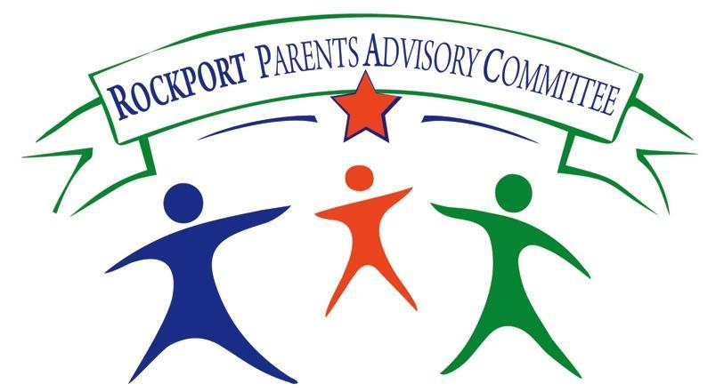

The Rockport Parents Advisory Committee (RPAC) invites parents, teachers and community members to attend a special evening event on the topic of ADHD presented by guest speaker, Dr. George Marinakis.

Dr. Marinakis obtained his doctorate in child clinical psychology at DePaul University in Chicago, where he worked with inner city youth and families. He completed his pre-doctoral internship at Franciscan Children’s Hospital in Brighton and then served as a child-family therapist on the Cognitive-Behavioral Inpatient Program of the hospital.

In 1991, he founded The Triumph Center and later expanded the program with Dr. Jeff Colucci. He currently serves as the clinical director of the Triumph Center, which is located in Reading, Beverly, and Lexington. Dr. Marinakis works closely with children, adolescents, and young adults as a school consultant, therapist, social skills group leader, and site director of Camp Triumph. He specializes in the areas of Autistic Spectrum Disorders, ADHD, social skills training, bullying prevention, school inclusion, and program development for children with emotional and behavioral disorders. Dr. Marinakis has been a guest speaker on a range of topics and currently consults to various public and private therapeutic schools in the greater Boston area. He enjoys being near the ocean in his condo in Rockport, where he spends the summer and much of the year with his family.

Date: January 15, 2015

Location: Rockport Middle School Library, 34 Jerdens Lane, Rockport

Time: 6pm

Find us on Facebook at https://www.facebook.com/rockportpac

RPAC interim co-chairs:
Ann Andrew annandrew@mac.com
Helga Marr helgamarr1@gmail.com

